QLN1 Task 2: Developing and Evaluating the NLP Model

Deven Lee
Western Governors University
D803: Natural Language Processing
September 13, 2025

Libraries and Tools
This work was executed in Python 3.13 using a lightweight, classical NLP stack based around scikit-learn. In order to identify meaningful unigrams and bigrams to be included in the model, text features were extracted using TF, a method that is widely adopted for short-text classification and is competitive with baselines (Xiao et al., 2024; Patuelli et al., 2024). Normalization used the English stopwords list from NLTK, and data loading and easy-to-use tabular/numerical operations were done using pandas and NumPy.
Scikit-learn provided training of models, metrics for evaluations, and cross-validations; models were pickled using joblib and plots (confusion matrix...) with matplotlib/seaborn. Data paths, preprocessing flags, TF–IDF settings, and hyperparameters are centralized in a YAML configuration file (config/config.yaml), making the project reproducible and simple to re-run in VS Code.

System Implementation
This system tackles SMS messages binary classification (spam/ham) using the public dataset SMS Spam Collection. The data are downloaded on the first run and then cached on the local machine (Alsaeedi et al., 2022). Preprocessing includes only lowercasing and punctuation removal, optional removal of numbers, and stopword filtering via NLTK. We split the data into train/test sets with the same 80/20 split but keeping the balance across classes.
The generated features are based on TF–IDF over unigrams and bigrams, with parameter-controlled document-frequency thresholds, a relevant choice for short texts (Xiao et al. 2024). In particular, for its speed, interpretability, and high performance in short-text tasks within sparse vector spaces, a Logistic Regression classifier with L2 regularization is used as a baseline ( Shyrokykh, Girnyk, & Dellmuth, 2023; Patuelli et al., 2024). The pipeline trains on the training set and tests on the held-out test set, storing the model, metrics, and confusion matrix in a models/ and reports/ directory to allow for reproducibility.
This is broken up into small, testable scripts: src/data_prep.py controls download/split and clean; src/train_baseline.py fits and evaluates the baseline and saves artifacts; and src/train_optimize.py conducts a hyperparameter search over TF-IDF and Logistic Regression. Utility functions handle text normalization in src/utils.py, and paths and boolean flags for repeatable runs are modifiable via config/config—yaml configuration.
Repository structure:
- Top level
  - README.md: Simple steps to set up and run the project.
  - requirements.txt: List of Python packages to install.
  - .gitignore: Tells Git to skip files like data and outputs.
  - branch_history.txt: The list of your commits and dates for submission.
- config folder
  - config.yaml: All the settings in one place (file paths, cleaning options, model choices, and tuning options).
- src folder
  - data_prep.py: Gets the dataset, cleans it, and splits it into train/test.
  - train_baseline.py: Trains the basic model and saves results (metrics and confusion matrix).
  - train_optimize.py: Tries different settings to improve the model.
  - utils.py: Small helper functions for cleaning text.
- Created when you run the code (not stored in Git)
  - data: Where the dataset files go.
  - Reports: Where metrics and the confusion matrix image are saved.
  - Models: Where the trained model file is saved.

Evaluation Summary
For the held-out test set, the model resulted in 0.984 accuracy, 0.984 weighted precision, 0.984 weighted recall, 0.983 weighted F1 score (seereports/metrics.json). These findings show good performance across classes, precision, and recall at similar levels. This suggests the classifier works well to pick up spam and minimizes false positives on legitimate messages. This is even more apparent in the confusion matrix, as expected for TF–IDF combined with a regularized linear classifier on short-text data (Shyrokykh, Girnyk, and Dellmuth 2023), misclassifications are minimal.
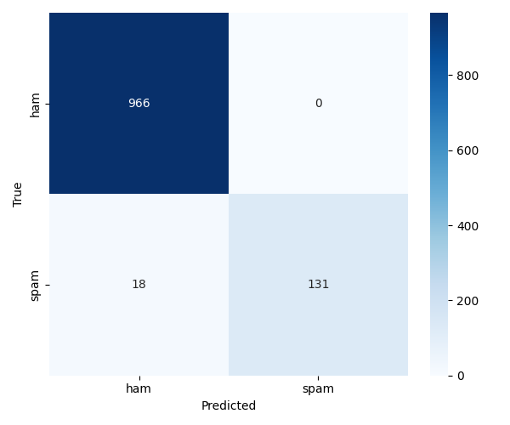
Confusion matrix:
Confusion Matrix

Optimization Summary
To mitigate against the risk of overfitting, in order to generalize better, we applied a GridSearchCV over TF–IDF and Logistic Regression parameters – setting the n-gram range, the minimum document frequency, and the inverse regularization strength C (Shyrokykh, Girnyk, & Dellmuth, 2023)—feature selection based on 5-fold cross-validation and weighted accuracy. The best configuration also utilized bigrams(1,2), min_df=3, and C=4.0, and it received a best cross-validated score of 0.9805, as seen in reports/best_params.json.
These parameters were chosen to account for the typical tradeoff of short-text pipelines: the inclusion of bigrams allows for capturing local phrase patterns that are not captured by single tokens, along with a slightly stronger regularization (higher C) in the SVM, which accounted for a bias-variance tradeoff produced by the sparseness of the feature space (Patuelli et al., 2024). Increasing the min_df ameliorates that by dropping terms with very low frequency, representing "noise" for generalization. Finally, the experiment could be extended by adding more baselines, such as linearSVC or MultinomialNB, as well as lemmatization and character n-grams, if better accuracy levels are pursued in the subsequent iterations (Patuelli et al., 2024).

References
Alsaeedi, Amal, Rafid Zubair, Munaim Khan, Vijey Thayananthan, et al. 2022. “A Systematic Literature Review on Spam Content Detection and Classification.” Applied Sciences 12 (3): 1281. https://doi.org/10.3390/app12031281.
Patuelli, Roberto, Luca Dugnani, Valeria Lanzilao, and Francesco Zambonelli. 2024. "Text Classification: How Machine Learning Is Driving Performance and What is Next." Information 16 (2): 130. https://doi.org/10.3390/info16020130.
Shyrokykh, Karina, Max Girnyk, and Lisa Maria Dellmuth. 2023. “Short Text Classification with Machine Learning in the Social Sciences: The Case of Climate Change on Twitter.” PLOS ONE 18 (9): e0290762. https://doi.org/10.1371/journal.pone.0290762.
Xiao, Lu, Qiaoxing Li, Qian Ma, Jiasheng Shen, Yong Yang, and Danyang Li. 2024. “Text Classification Algorithm of Tourist Attractions Subcategories with Modified TF-IDF and Word2Vec.” PLOS ONE 19 (10): e0305095. https://doi.org/10.1371/journal.pone.0305095.

